Computing Eigen Values in R:

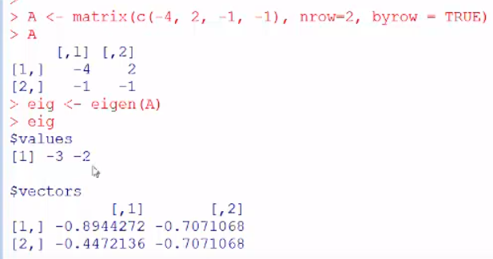

Multiply and the values change:

